MiniCase #1

Wikipedia: Disrupting the Encyclopedia Business
WIKIPEDIA IS OFTEN the first source consulted for information about an unfamiliar topic, but this was not always the case. For almost 250 years, Encyclopaedia Britannica was the gold standard for authoritative reference works, delving into more than 65,000 topics with articles by some 4,000 scholarly contributors, including many by Nobel laureates. The beautiful leather-bound, multivolume set of books made a decorative item in many homes. In the early 1990s, when total sales for encyclopedias were over $1.2 billion annually, Encyclopaedia Britannica was the undisputed market leader, holding more than 50 percent market share and earning some $650 million in revenues. Not surprisingly, its superior differentiated appeal was highly correlated with cost, reflected in its steep sticker price of up to $2,000.
Two innovation waves disrupted the encyclopedia business and over time drove Encyclopædia Britannica, Inc., the publisher of its namesake reference, to abandon its print version. Innovation—the successful introduction of a new product, process, or business model—is a powerful driver in the competitive process.
The first wave was initiated by the introduction of Encarta. Banking on the widespread diffusion of the personal computer, Microsoft launched its electronic encyclopedia Encarta in 1993 at a price of $99. Although some viewed it as merely a CD version of the lower-cost and lower-quality Funk & Wagnalls encyclopedia sold in supermarkets, Encarta still took a big bite out of Britannica’s market. Within only three years, the market for printed encyclopedias had shrunk by half, along with Britannica’s revenues, while Microsoft sold over $100 million worth of Encarta CDs. This level of disruption was compounded by a later development that overtook both Encarta and printed encyclopedias.

©BORIS ROESSLER/EPA/Newscom
The second wave of disruption through innovation ultimately played the major role in driving the Encyclopaedia Britannica out of printed media. In January 2001, internet entrepreneur Jimmy Wales launched Wikipedia, the free online multi-language encyclopedia. In Hawaiian, wiki means quick, referring to the instant do-it-yourself editing capabilities of the site. Jimmy Wales identifies September 11, 2001, as a “Eureka moment” for Wikipedia. Before 9/11, Wikipedia was a small niche site. Immediately following the terrorist attacks, millions of people visited the site to learn more about what they had seen and heard on the news. Massive numbers of queries for search terms such as Al-Qaeda, the World Trade Center, the Pentagon, the different airlines and airports involved, etc., made Wales realize that Wikipedia “could be big.” Some 17 years later, Wikipedia is visited about 200 times a second, or 500 million times a month! It is ranked number five on the list of the world’s most visited websites, just behind Google, Facebook, YouTube (also owned by Google/Alphabet), and Baidu, but before well-known sites such as Yahoo, Amazon, Reddit, and others. Wikipedia has more than 40 million articles in nearly 300 languages, including some 5 million entries in English. Roughly 12,000 new pages spring up each day.
page 492The combined effect of these two innovations devastated the business of printed encyclopedias. Sales of the beautiful leather-bound Encyclopaedia Britannica volumes declined from a peak of 120,000 sets in 1990 to a mere 12,000 sets in 2010. As a consequence, Encyclopaedia Britannica Inc. announced in 2012 that it no longer would print its namesake books. Its content is now accessible via a paid subscription through its website and apps for mobile devices. Encarta, which began the disruptive cycle and had developed its own online models to supplement delivery via CD, also fell. Microsoft ceased all Encarta versions in 2009.

The Power of Free, Open, and Easy
Wikipedia is a nonprofit, advertising-free, social entrepreneurship venture that owes its success to being free to all users, open to improvement by all, and easy to use, with no registration requirements and no advertisements to suffer through.
WHO PAYS FOR FREE?. Wikipedia is exclusively financed by donations. The site runs regular calls for donations using slogans such as: “Please help us feed the servers,” “We make the Internet not suck. Help us out,” and “We are free, our bandwidth isn’t!”¹ Calls for donations also come in the form of personal appeals by co-founder Wales. These appeals are effective. In 2015, people donated more than $50 million in 70 currencies, mostly via a large number of small donations through its website. When asked why Wales wouldn’t want to monetize one of the world’s most successful websites by placing targeted ads for example, Wales responded that running Wikipedia as a charity “just felt right, knowledge should be free for everyone.”² The question arises whether the donation model is sustainable given not only the increasing demand for Wikipedia’s services, but also the emergence of competitors.
OPEN SOURCE SUPPORTS QUALITY. Wikipedia’s slogan is the free encyclopedia that anyone can edit. Since it is open source, any person, expert or novice, can contribute content and edit pages using the handy “edit this page” button. Although Wikipedia has 70 million registered accounts, and any of these people can edit content, some 100,000 Wikipedians represent the core. They volunteer as editors and authors, representing a global community of widely diverse views.
The Upside How accurate is the result? What quality is the information? Although Wikipedia’s volume of English entries is more than 500 times greater than that of the Britannica, the site is not as error-prone as you might think. Wikipedia relies on the wisdom of the crowds, which assumes “the many” often know more than “the expert.” Moreover, user-generated content needs to be verifiable by made reliable sources such as links to reputable websites. A peer-reviewed study by Nature of selected science topics found that the error rates of Wikipedia and Britannica were roughly the same.
The Downside Wikipedia’s crowdsourcing approach to user-generated content is not without criticism. The most serious criticisms are that the content may be unreliable and not authoritative, that it could exhibit systematic bias, and that group dynamics might prevent objective and factual reporting. Therefore many users approach Wikipedia with caution; ideally, careful researchers go to and review the sources of Wikipedia articles for verification.
EASY. Despite real or perceived drawbacks, most users will verify that Wikipedia remains easy to use, especially free of the time-consuming apparatus found on sites that use a marketing-based business model.

What Next for Wikipedia?
Every year or so articles come out questioning the ability of Wikipedia to survive, given its uncertain funding and amorphous (and possibly shrinking) body of active volunteer editors.³ Others note that with expanding use, the demands on its servers and infrastructure threaten to bring the enterprise down.
In the meanwhile, social entrepreneur and founder Jimmy Wales keeps going. In 2017 he proposed a new and parallel effort, Wikitribune, aimed at fixing “broken” journalism.⁴ His goal? Evidence-based journalism following a model very similar to Wikipedia.

DISCUSSION QUESTIONS
- The MiniCase provides an example of how advancements in technology can render traditional business models obsolete. With the introduction of its CD-based Encarta, Microsoft destroyed about half the value created by Britannica. In turn, Wikipedia moved away from Britannica’s page 493and Microsoft’s proprietary business models to an open-source model powered by user-generated content and made available to anyone on the internet. In doing so, it destroyed Encarta’s business, which Microsoft shut down in 2009. At the same time, Wikipedia created substantial benefits for users by shifting to the open-source model for content. Because Wikipedia was able to create value for consumers by driving the price for the end user to zero and making the information instantly accessible on the internet, there is no future for printed or CD-based encyclopedias.
  - What are the general take-aways in regard to innovation as a driver of competition?
  - How can existing firms respond to disruptions in their industry?
- The founder of Wikipedia, Jimmy Wales, is a social entrepreneur. Raised in Alabama, Wales was educated by his mother and grandmother who ran a nontraditional school. In 1994, he dropped out of a doctoral program in economics at Indiana University to take a job at a stock brokerage firm in Chicago. In the evenings he wrote computer code for fun and built a web browser. During the late 1990s internet boom, Wales was one of the first to grasp the power of an open-source method to provide knowledge on a very large scale. What differentiates Wales from other web entrepreneurs is his idealism: Wikipedia is free for the end user and supports itself solely by donations. Wales’ idealism is a form of social entrepreneurship: His vision is to make the entire repository of human knowledge available to anyone, anywhere for free.
  - If you were the founder of Wikipedia, would you want to monetize the business? Why or why not?
  - What are the pros and cons of for-profit versus nonprofit business? Where do you come down?
- How can Wikipedia maintain and grow its ability to harness the crowdsourcing of its “Wikipedians” to maintain high-quality and quickly updatable content?
- As Wikipedia keeps growing, do you think it can continue to rely exclusively on time and money donations? Why or why not? What other business models could be considered? Would any of those “violate the spirit of Wikipedia”? Why or why not?
- What, if anything, should Wikipedia do to ensure that its articles present a “neutral point of view”? Shouldn’t the crowdsourcing approach ensure objectivity? Does a “neutral point of view” matter to Wikipedia’s sustainability? Why or why not?
- Qualify Wales’ efforts around Wikitribune as to the degree to which it has the same disruptive and innovative benefits as Wikipedia.

MiniCase #2

LEGO’s Turnaround: Brick by Brick
IN THE DECADE between 2006 and 2016, LEGO—the famous Danish toy company—grew fivefold from a bit over $1 billion in revenues to $6 billion (see Exhibit MC12.1). In 2016 LEGO delivered its best results in terms of top-line revenues and bottom-line profits in its 85-year history. It beat out long-time rivals Mattel and Hasbro to become the world’s largest and most profitable toy company. How did this privately held toy company from an obscure town in Denmark beat the well-funded and publicly traded U.S. companies Hasbro and Mattel?
EXHIBIT MC12.1 / Revenues of Mattel, Hasbro, and LEGO (in $ billion), 2002–2016
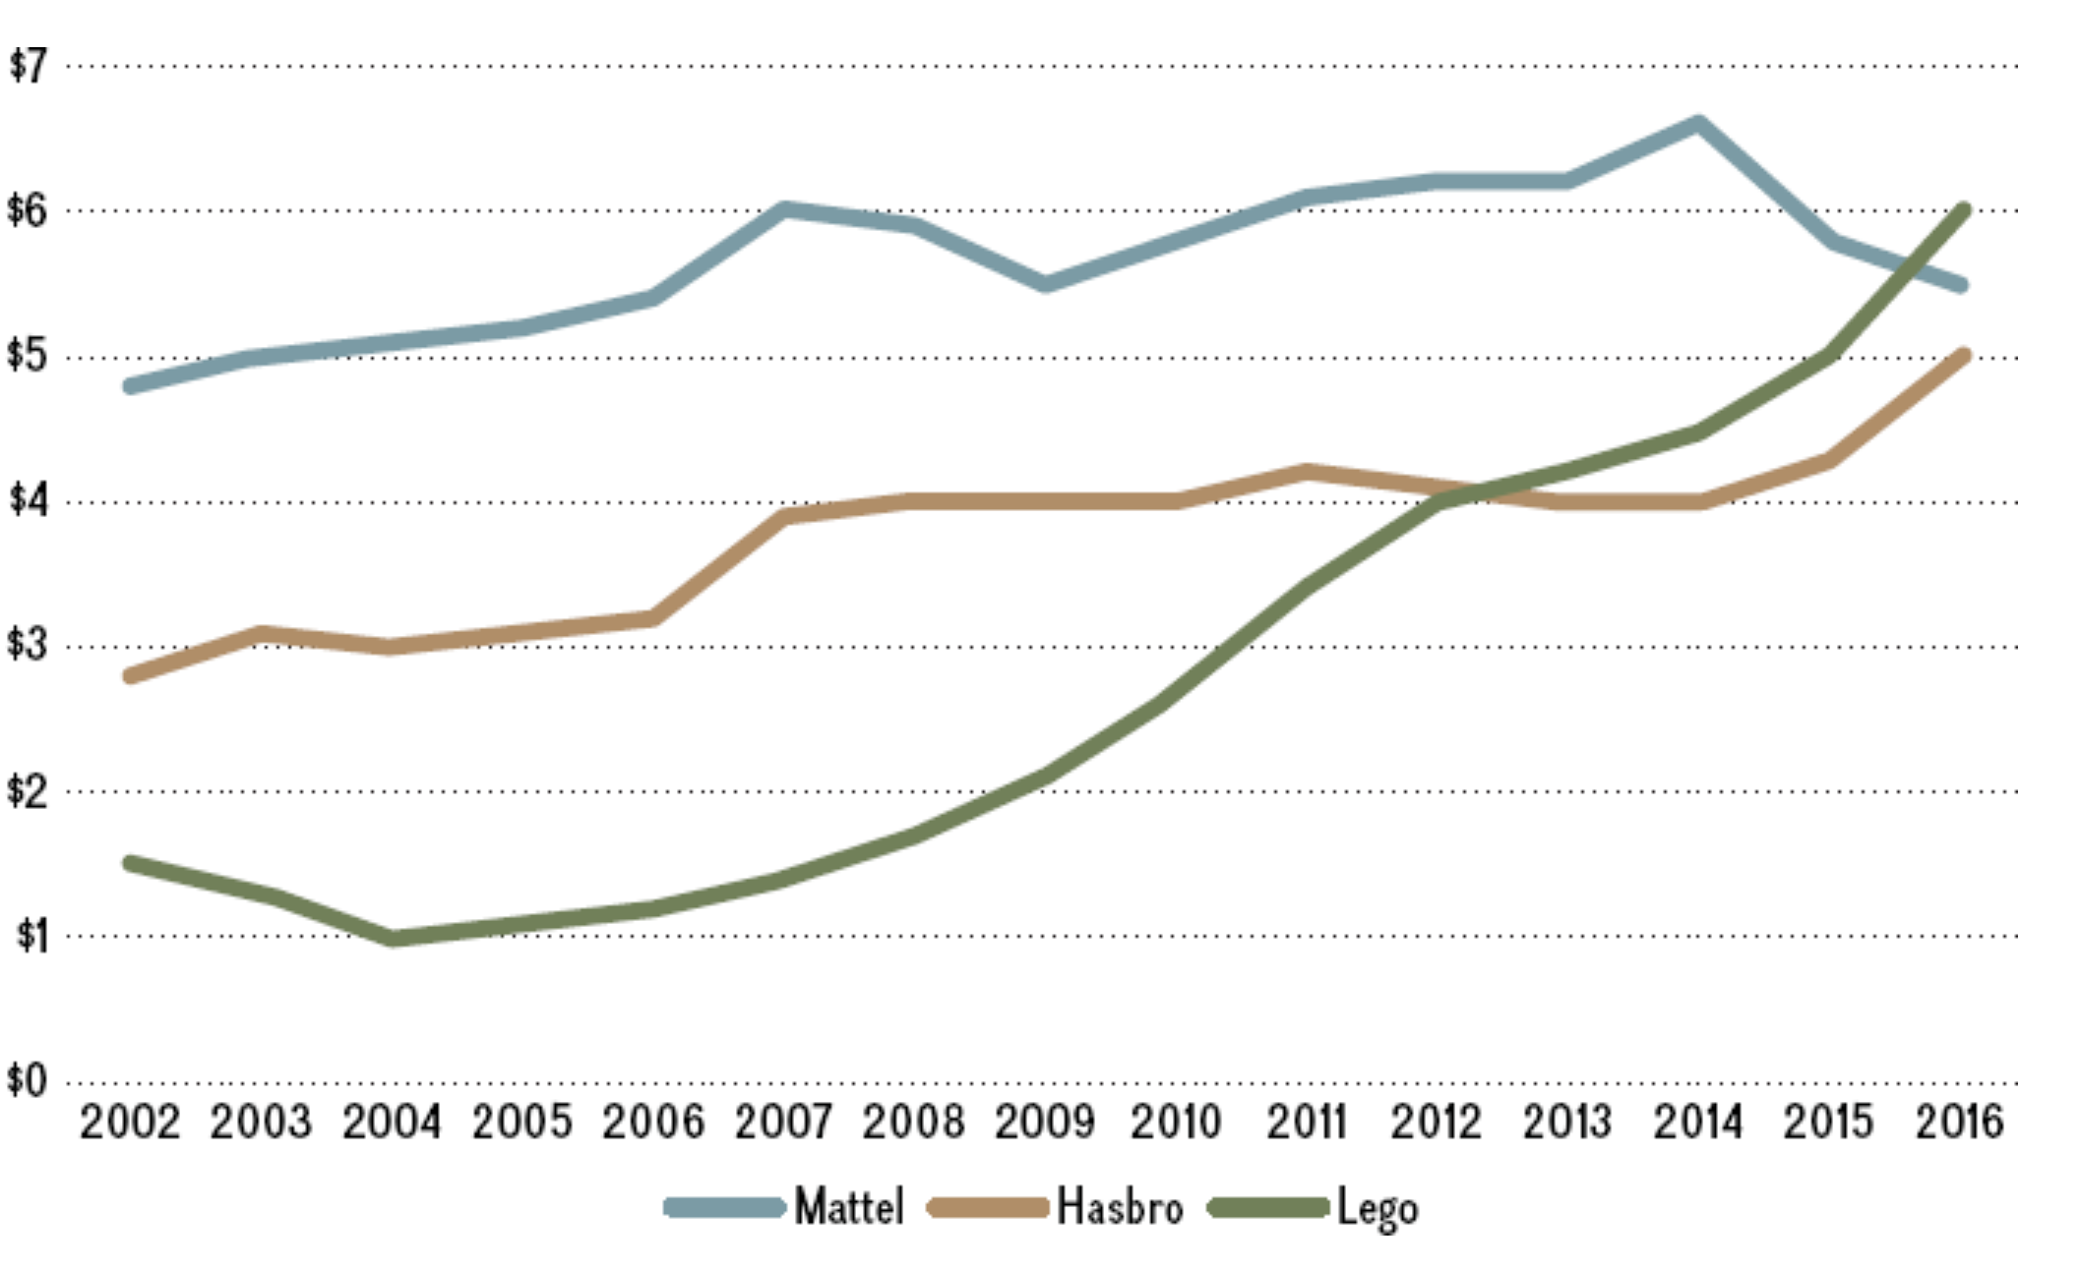
SOURCE: Depiction of publicly available data.
Rediscovering, leveraging, and extending its core competency allowed a successful revival for a company that was floundering in the early 2000s. How did LEGO construct a successful turnaround? To answer this question, we first need to understand a bit of the history of this Danish wonder company.

LEGO’s Humble Beginnings
The company was founded in 1932 by Ole Kirk Kristiansen. The name is a contraction of the Danish words Leg godt, which means “play well.” Only later did LEGO executives realize that le go in Latin also means “I assemble.” Throughout its history, LEGO has had numerous formidable competitors, but it has outperformed all of them. Tinkertoys were more complex; Lincoln Logs were limited in what could be constructed; traditional blocks had nothing to hold them together and were too large to show much detail. LEGO bricks were the right balance of simplicity, versatility, and durability.
LEGO competes for the attention of children and their parents, who buy the product. Plus, there is also a sizable group of adult LEGO fans. In the wake of the personal computer revolution in the 1990s, the popularity of LEGO began to wane because of attractive alternatives for children such as gaming consoles and computer games. By 1998, LEGO was in trouble. The Danish toymaker hired a highly touted turnaround expert to change its fortune. Unfortunately, he had no background in the toy industry. To make matters worse, the new executive decided that LEGO’s hometown of Billund, Denmark, with 6,000 people, was too provincial. He continued to live in Paris and either commute or run the company remotely.

The LEGO Movie was a huge hit: The 3D computer-animated film had a budget of $60 million, but grossed some $500 million at the box office, making it one of the top five movies in 2014. Similarly, the 2017 The LEGO Batman Movie was almost as successful. With a budget of $80 million, it grossed over $310 million at the box office.
©Mim Friday/Alamy Stock Photo
Things at LEGO went from bad to worse. It started hyperinnovating and diversified into too many areas, too quickly, and too far away from its core. Among a whole slew of other innovation failures, the company created a Saturday morning cartoon called “Galidor,” which flopped. During this time period, it also decided to become a lifestyle company and to offer LEGO-branded clothing and accessories.
LEGO’S TURNAROUND. By 2003, LEGO was on the verge of bankruptcy. To avoid this fate, the closely held private company, owned by the Kristiansen family page 485since its inception, needed to do something drastic and quickly. Almost out of desperation, it hired Jørgen Vig Knudstorp as CEO. His résumé was quite unusual to say the least: He was only 35 years old (in comparison, the average age for a Fortune 500 CEO is 55 years), held a doctorate in economics, and was a former academic. Knudstorp had transitioned to McKinsey, one of the world’s premier strategy consulting firms.
Knudstorp decreed that LEGO must “go back to the brick” and focus on core products. As a result of the strategic refocusing, LEGO divested a number of assets including its theme parks. It also drastically culled its product portfolio by almost 50 percent, from some 13,000 pieces to 7,000. At the same time as Knudstorp focused LEGO again on its fundamental strengths, he was also careful to balance exploitation—applying current knowledge to enhance firm performance in the short term—with exploration—searching for new knowledge that may enhance a firm’s future performance. This allowed LEGO to improve the performance of traditional product lines, while at the same time to innovate, but this time in a much more disciplined manner.
In particular, LEGO increased sales of its well-known existing products by strengthening the interoperability of various LEGO pieces with other sets to encourage user innovation and creativity. To drive innovation, LEGO has brought its adult fans into the product development process to leverage crowdsourcing—obtaining ideas from a large fan base using online forums and other internet-based technologies. To drive future growth, LEGO has been much more careful with its product extensions. In the past LEGO licensed its brand freely to other brands, including Star Wars, Indiana Jones, Harry Potter, the Lord of the Rings, Batman, the Simpsons, and Iron Man. But the benefits from these licensing agreements accrued mainly to the existing brands, because LEGO did not own the more critical intellectual property.
Knudstorp instead focused on owning and leveraging the core intellectual property. The LEGO Movie in 2014 was a particular high for the company, grossing $500 million in the first year of its release on a $60 million budget. Unlike in previous movie tie-ins, LEGO owned the intellectual property, which meant LEGO did not need to split profits with existing brands. In 2017, the company repeated this feat with The LEGO Batman Movie, also a computer-animated superhero comedy film that was almost as successful: With a budget of $80 million, it grossed over $310 million, making it one of the top-10 box office hits in 2017.
page 486CHALLENGES. Although LEGO grew more than fivefold after Knudstorp took over, it faces a number of challenges. LEGO needs to strengthen its triple-bottom-line performance along economic, social, and ecological dimensions, and address globalization challenges.
LEGO must address ecological concerns in the face of growing consumer criticism: Its signature bricks are made from petroleum-based plastic. The company is searching for an environmentally friendly material to replace its bricks, which that date to 1963. To reduce its relatively large carbon footprint, the company is spending millions on a 15-year R&D project in hope of finding an eco-friendly alternative. The goal is to invent and then manufacture bricks cost-effectively from a new bio-friendly material that will be virtually indistinguishable from the current blocks. It is a difficult problem to solve because LEGO bricks are precisely engineered to four-thousandths of a millimeter, hold a large range of colors well, and even make a sound when two pieces are snapped together.
To continue to grow, LEGO must become stronger in emerging growth markets such as China. LEGO is a comparatively new entry into China because of the fear that knockoff bricks have sufficiently damaged its brand. Knockoffs, which are rampant in China, are of inferior quality and even have injured some consumers. Yet, with growth in Western markets plateauing and a larger number of Chinese entering the middle class, this market opportunity is critical to LEGO’s future success. Moreover, Chinese government officials endorse LEGO as a “mind toy,” which helps children to develop creativity. The hope is that creative children will grow up to drive innovation in firms, something many critics say Chinese companies lack. In addition, Chinese parents and grandparents are eager to spend money on things that are perceived to help their offspring to excel academically. In general, parents around the globe are more than happy to spend money on games that get their children away from mobile devices, computers, and game consoles.

In 2017, Bali Padda was appointed CEO of LEGO, but served in that position for only eight months. Does this sudden change in leadership spell trouble for LEGO ahead?
©NIKOLAI LINARES/AFP/Getty Images
To take advantage of the growth opportunity in China and other Asian countries such as India and Indonesia, LEGO opened offices in Shanghai and Singapore as well as a factory in Jiaxing, China. To address the globalization challenge more generally, LEGO also needs to internationalize its management. At this point, it is a local, small-town company that happened to be successful globally, especially in the West. LEGO hopes to become a global company that happens to have its headquarters in Billund, Denmark.
LEGO is also experiencing a change in leadership. After a widely successful turnaround, Jørgen Vig Knudstorp stepped down as CEO in 2017. His successor was Bali Padda, who had been LEGO’s chief operating officer (COO), and thus second in command. The Indian-born British Padda was the first non-Danish CEO to run the company in its 85-year history. Just eight months into his tenure, Padda was replaced as LEGO CEO by Niels Christiansen, a Dane who comes from outside the toy industry. Christiansen headed the industrial group Danfoss and was hailed for moving it into the digital age. LEGO is hoping that he will do the same for the Danish toymaker.

DISCUSSION QUESTIONS
- Why did LEGO face bankruptcy in the early 2000s? In your reasoning, focus on both external and internal factors.
- What is LEGO’s core competency? Explain.
- Apply the core competence–market matrix to show how LEGO leveraged its core competence into existing and new markets over the past decade.
- In terms of revenue growth, LEGO experienced a competitive advantage over both Hasbro and Mattel since 2007 because it grew much faster. What explains LEGO’s competitive advantage?
- What must LEGO do to sustain its competitive advantage in the future? One avenue to tackle this question is to think about diversification, both along products but also geography. Another

MiniCase #3

Disney: Building Billion-Dollar Franchises
WITH $55 BILLION in annual revenues in 2017, Disney is the world’s largest media company and is renowned for its Walt Disney Studios and the popular Walt Disney Parks and Resorts. Over the past decade, Disney has grown through a number of high-profile acquisitions, including Pixar (2006), Marvel (2009), and Lucasfilm (2012), the creator of Star Wars. All this was done with the goal of building billion-dollar franchises based on movie sequels, park rides, and merchandise. In 2017, Disney revealed even bigger ambitions.

Star Wars: The Force Awakens is part of the global Star Wars franchise. This sequel alone is estimated to turn into a $10 billion franchise for Disney.
©Mim Friday/Alamy Stock Photo

Disney’s Corporate Strategy
As a diversified media company, Disney is active in a wide array of business activities—movies, amusement parks, cable and broadcast television networks (ABC, ESPN, and others), cruises, and retailing. It became the world’s leading media company to a large extent by pursuing a corporate strategy of related-linked diversification. That is, some, but not all, of Disney’s business activities share common resources, capabilities, and competencies.
Disney executes its corporate strategy by entering alliances and acquiring other media businesses to create theme-based franchises. The corporate strategy of creating billion-dollar franchises through diversification is Disney’s main focus. CEO Bob Iger leads a group of about 20 executives whose sole responsibility is to hunt for new billion-dollar franchises. This group of senior leaders decides top-down which projects are a go and which are not. They also allocate resources to particular projects. Disney has even organized its employees in the consumer products group around franchises such as Frozen, Toy Story, Star Wars, and other cash cows.
The corporate strategy around building billion-dollar franchises is certainly paying off: Disney has seen a steady growth to its top line, and it earned some $10 billion in profits in 2016. Its stock rose more than 350 percent between 2010 and 2017, outperforming rivals such as Time Warner, Sony’s Columbia Pictures, and 21st Century Fox.

Disney and Pixar: “Try Before You Buy”
To understand Disney’s corporate strategy of growing through acquisition, let’s look at one of the most successful deals in recent history: Disney acquired Pixar, and then built a number of billion-dollar franchises around it. It all started with a strategic alliance. Pixar started as a computer hardware company producing high-end graphic display systems. One of its customers was Disney. To demonstrate the graphic display systems’ capabilities, Pixar produced short, computer-animated movies. Despite being sophisticated, Pixar’s computer hardware was not selling well, and the new venture was hemorrhaging money. To the rescue rode page 495not Buzz Lightyear, but Steve Jobs. Shortly after being ousted from Apple in 1986, Jobs bought the struggling hardware company for $5 million and founded Pixar Animation Studios, investing another $5 million into it. The Pixar team, led by Edwin Catmull and John Lasseter, then transformed the company into a computer-animation film studio.
To finance and distribute its newly created computer-animated movies, Pixar entered a strategic alliance with Disney. Disney’s distribution network and its stellar reputation in animated movies were critical complementary assets that Pixar needed to commercialize its new type of films. In turn, Disney was able to rejuvenate its floundering product lineup, retaining the rights to the newly created Pixar characters and to any sequels.
Pixar became successful beyond imagination as it rolled out one blockbuster after another: Toy Story (1, 2, and 3), A Bug’s Life, Monsters Inc., Finding Nemo, The Incredibles, and Cars, grossing several billion dollars. Given Pixar’s huge success and Disney’s abysmal performance with its own releases during this time, the bargaining power in the alliance shifted dramatically. Renegotiations of the Pixar–Disney alliance broke down in 2004, reportedly because of personality conflicts between Steve Jobs and then-Disney Chairman and CEO Michael Eisner.
After Robert Iger was appointed CEO, Disney acquired Pixar for $7.4 billion in 2006. The success of the alliance demonstrated that the two entities’ complementary assets matched, and it gave Disney an inside perspective on the value of Pixar’s core competencies in the creation of computer-animated features. Integrating Pixar allowed Disney to transfer and apply some of its unique competencies including marketing, brand building, product extensions.

Acquisitions Ever After . . .
In 2009, Disney turned to acquisitions again. The acquisition of Marvel Entertainment for $4 billion added Spider-Man, Iron Man, The Incredible Hulk, and Captain America to its lineup of characters. Marvel’s superheroes grossed a cumulative $15 billion at the box office, with The Avengers bringing in some $2 billion. In 2012, Mickey Mouse’s extended family was joined by Darth Vader, Obi-Wan Kenobi, Princess Leia, and Luke Skywalker when Disney acquired Lucasfilm for more than $4 billion.
In 2014, Disney acquired Maker Studios, a YouTube-based multichannel network, for $675 million. Under Disney, Maker Studies is no longer focused on providing some 60,000 YouTube creators with support by promoting their channels and selling ads. Rather, Maker now the marching orders to focus on no more than the top 250 YouTube content creators with large followings. The goal is to build billion-dollar franchises in the new on-demand TV space. One Maker Studios early success story was YouTube megastar PewDiePie, who at one point had the most successful YouTube channel and for many years was one of the highest-profile stars on YouTube. In 2017, however, Disney cut ties with PewDiePie following his posting of videos in which he made inflammatory remarks, not in line with Disney’s values.

Building Billion-Dollar Franchises
After taking the reins, CEO Iger transformed a lackluster Disney following a decade or so of inferior performance by refocusing it around what he calls franchises, which generally begin with a big movie hit and are followed up with derivative TV shows, theme park rides, video games, toys, clothing such as T-shirts and PJs, among many other spin-offs. Rather than churning out some 30 movies per year as it did before Iger, Disney now produces about 10 movies per year, focusing on creating box-office hits. Disney’s annual movie lineup is dominated by such franchises as Stars Wars and Marvel superhero movies and also by live-action versions of animated classics such as Cinderella and Beauty and the Beast. The biggest Disney franchises that started with a movie hit include the Pirates of the Caribbean (with the franchise grossing more than $4 billion), Toy Story (over $2 billion), Monsters Inc. (close to $2 billion), Cars (over $1 billion), and, of course, Frozen.
The 2013 animated movie Frozen (made by Walt Disney Animation Studios run by Pixar execs Catmull and Lasseter) has grossed over $1.5 billion, making it the most successful animated movie ever. To further build its Frozen franchise, Disney is working on a sequel of its animated movie hit for release in late 2019, and in the meanwhile it has spun off several shorter films, much merchandise, and a dreamlike ride through the fictional world of Arendelle at Disney World’s Epcot Center, replacing a previous attraction that had grown stale.
The Star Wars franchise, however, is clearly the crown jewel in Disney’s lineup of billion-dollar franchises. The 2015 Star Wars sequel The Force Awakens grossed over $2 billion on the big screen, making it the third-best-selling movie ever after Avatar and Titanic.
page 496

Intergalactic Finance: The Star Wars Franchise Is Worth $10 Billion
The numbers generated around the Star Wars franchise do seem fantastic. First, just consider the grosses of the movies. Although The Force Awakens grossed over $2 billion in box-office receipts on a budget of about $260 million, NYU finance professor Aswath Damodaran estimates the final gross receipts of the 2015 Star Wars sequel to be $10 billion.
HOW ONE MOVIE GROSSES $10 BILLION. Professor Damodaran extrapolated add-on revenue by using historical data, so he could project anticipated revenues not just from The Force Awakens but also from other announced sequels in the pipeline. Here is how a simple version of his model plays out, based on the reported box-office receipts the 2015 for sequel of roughly $10 million. Note that add-on revenue is computed using a multiplier (shown in parentheses) of box-office receipts.¹
- Box-office receipts: $2 billion.
- Streaming revenue (1.2): $2.4 billion.
- Toys and merchandise (1.8): $ 3.6 billion
- Books and e-books (0.2): $ 0.4 billion.
- Gaming (0.5): $ 1 billion.
- TV shows and other (0.5): $ 1 billion.
Thus the total gross receipts for The Force Awakens are $10.4 billion.
VALUATION OF A FRANCHISE. By coincidence, Damodaran ultimately values the entire Star Wars franchise at the same amount—around $10 billion. He therefore concludes that Disney’s $4 billion price tag for Lucasfilm was a good investment. Again, the astonishing valuation of the franchise—or the reveal of the likely true gross receipts of a new film in the franchise—is explained by Disney’s ability to build revenue on top of billion-dollar franchises through product extensions and add-ons. The Star Wars empire has a far reach in many corners of commerce, let alone in the galaxy.

Clouds on Disney’s Horizon
While things have been sunny in Southern California, where Disney is headquartered, there are clouds on the horizon, which is to say Disney has been facing a number of potential challenges.
- Risks of Relying on a Few Big Franchises. Disney’s approach is risky. What if the pipeline dries up? That is, how sustainable is an acquisition-led growth strategy? Not many media companies remain of the same caliber as Pixar, Marvel, or Lucasfilm.
- Losing Originality. Critics worry that focusing on billion-dollar franchises hampers Disney’s originality. Moviegoers could write off Disney’s offerings as too predictable.
- Problems on the TV Side. Roughly half of Disney’s profits come from its TV networks ESPN, ABC, and others. Yet that industry is in disruption. People spend more time and sometimes money watching content online via YouTube, Netflix, Hulu, and other streaming services, and they watch less TV. This means the numbers of TV viewers and cable subscribers are in decline.
- Underperforming Acquisitions. Disney’s acquisitions have not been uniformly successful. While Disney won big with franchise-based studios Pixar and Lucasfilm, it has also lost money and focus with the acquisition of technology companies. Examples include online video producer Maker Studios (2014) and social gaming company Playdom Inc. (2010).
- Issues of Succession. Who will succeed Robert Iger as CEO? He was the architect of Disney’s corporate strategy of building billion-dollar franchises and implemented it to achieve new levels of growth. Appointed in 2005, he originally planned to step down in 2015. Most recently he extended his tenure until 2019. With no clear internal candidates to take over the mantle as CEO, Disney has no heir apparent.
These challenges were suddenly cast in a new light when Iger announced a strategic shift, significantly changing the complexity of several of these challenges.

Iger Joins the Disruption
In 2017 Iger announced that Disney would launch two streaming services similar to Netflix. One service would focus on ESPN’s audience and start in 2018, the other on Disney’s huge catalog of original content and start in 2019.
AN ESPN STREAMING SERVICE. While the ESPN service will focus on ESPN’s audience, it will not cannibalize the existing ESPN stations. The ESPN page 497streaming service will carry new sports content that extends the ESPN cable content—if you already subscribe to ESPN on cable, you would be able to also watch the cable events over the streaming service.
This decision may reflect the importance that cable companies place on the ESPN sports channels as their single biggest draw overall, their “must-have” component of the cable offering. But the cable companies were increasingly frustrated by rising costs, especially as the costs affected viewership. ESPN, often the most expensive part of the cable bundle, accounts for over $8 per month of cable charges even when distributed across all subscribers, by some estimates.
Cable companies wanted Disney to rein in fees because subscribers were growing more restive and some had already jumped ship. ESPN at its peak had 100 million subscribers, but has lost close to 12 million subscribers in the past five years. And cable companies feared such a loss was just the beginning of a subscriber revolt, with subscribers demanding ESPN become unbundled from cable packages.
A FRANCHISE STREAMING SERVICE. While the proposed ESPN streaming service may not adversely impact ESPN channels, the decision to create a streaming service for many of Disney’s blue-chip franchises has much greater potential, with special impact on Netflix.
Iger has announced that Disney will be pulling most of its movies from Netflix over the next two years. Some analysts see this move as reducing the value of Netflix to subscribers. Others see the content being pulled as relatively minor. First, Disney has not yet decided if it would pull its Marvel or Star Wars movies from Netflix, and second, none of the Marvel series (think the Marvel Defenders, Jessica Jones, and Luke Cage) will go because they are coproductions with Netflix.
TECHNOLOGY IS KEY. To make this streaming happen, Disney is making one highly focused technology acquisition. Last year it acquired a third of BamTech— which supplies streaming services for HBO and many sports events—and has an option to buy a controlling interest.
EARLY DAYS. It is too early yet to tell how this shift in corporate strategy will play out. But what is clear now is that in the face of various issues noted above, Disney under Iger has decided to increase its independence in unsettled media markets. Instead of fighting the disruption, Disney is joining it.

DISCUSSION QUESTIONS
- Before announcing its streaming services, what type of corporate strategy was Disney pursuing? Which core competencies were shared and how?
- Why do you think Disney’s acquisitions of Pixar, Marvel, and Lucasfilm were so successful, while other media interactions such as Sony’s acquisition of Columbia Pictures and News Corp.’s acquisition of Myspace were much less successful?
- Do you think focusing on billion-dollar franchises has been a good corporate strategy for Disney? What are pros and cons of this strategy?
- Given the build-borrow-or-buy framework, do you think Disney should pursue alternatives to acquisitions? Why or why not?
- Given Disney’s focus on creating and monetizing billion-dollar franchises, some industry observers now view Disney more as a global consumer products company like Nike rather than a media company. Do you agree with this perspective? Why or why not? What strategic implications would it have if Disney is truly a global consumer products company rather than a media and marketing company?
- What type of corporate strategy is evidenced in Disney’s announced streaming services? What are the potential benefits and risks of such strategies?

MiniCase #4

Hollywood Goes Global
BLOCKBUSTER MOVIES have always been a quintessentially American product. Globalization, however, has changed the economics of the movie industry. Foreign ticket sales for Hollywood blockbusters made up 50 percent of worldwide totals in 2000. By 2016, they made up more than 70 percent, with some movies (e.g., Transformers: Age of Extinction) grossing 80 percent of total box-office receipts overseas. Of the total $38.6 billion that Hollywood movies grossed in 2016, more than $27.2 billion came from outside North America. Today, largely because of the collapse of DVD/Blu-ray sales, Hollywood would be unable to continue producing big-budget movies without foreign revenues. Foreign sales now make or break the success of newly released big-budget movies.
Avatar is the highest-grossing movie to date, earning almost $3 billion since its release in 2009. Non-U.S. box-office sales account for close to 75 percent of that number. Avatar was hugely popular in Asia, especially in China, where the government gave permission to increase the number of movie theaters showing the film from 5,000 to 35,000. Another of James Cameron’s popular films, Titanic, grossed almost 70 percent of its close to $2 billion earnings in overseas markets. Exhibit MC16.1 depicts the lifetime revenues of Hollywood’s all-time blockbuster movies, broken down into domestic and foreign.
page 499
EXHIBIT MC16.1 / Lifetime Revenues of Top 20 Hollywood Blockbuster Movies (release year in parentheses)
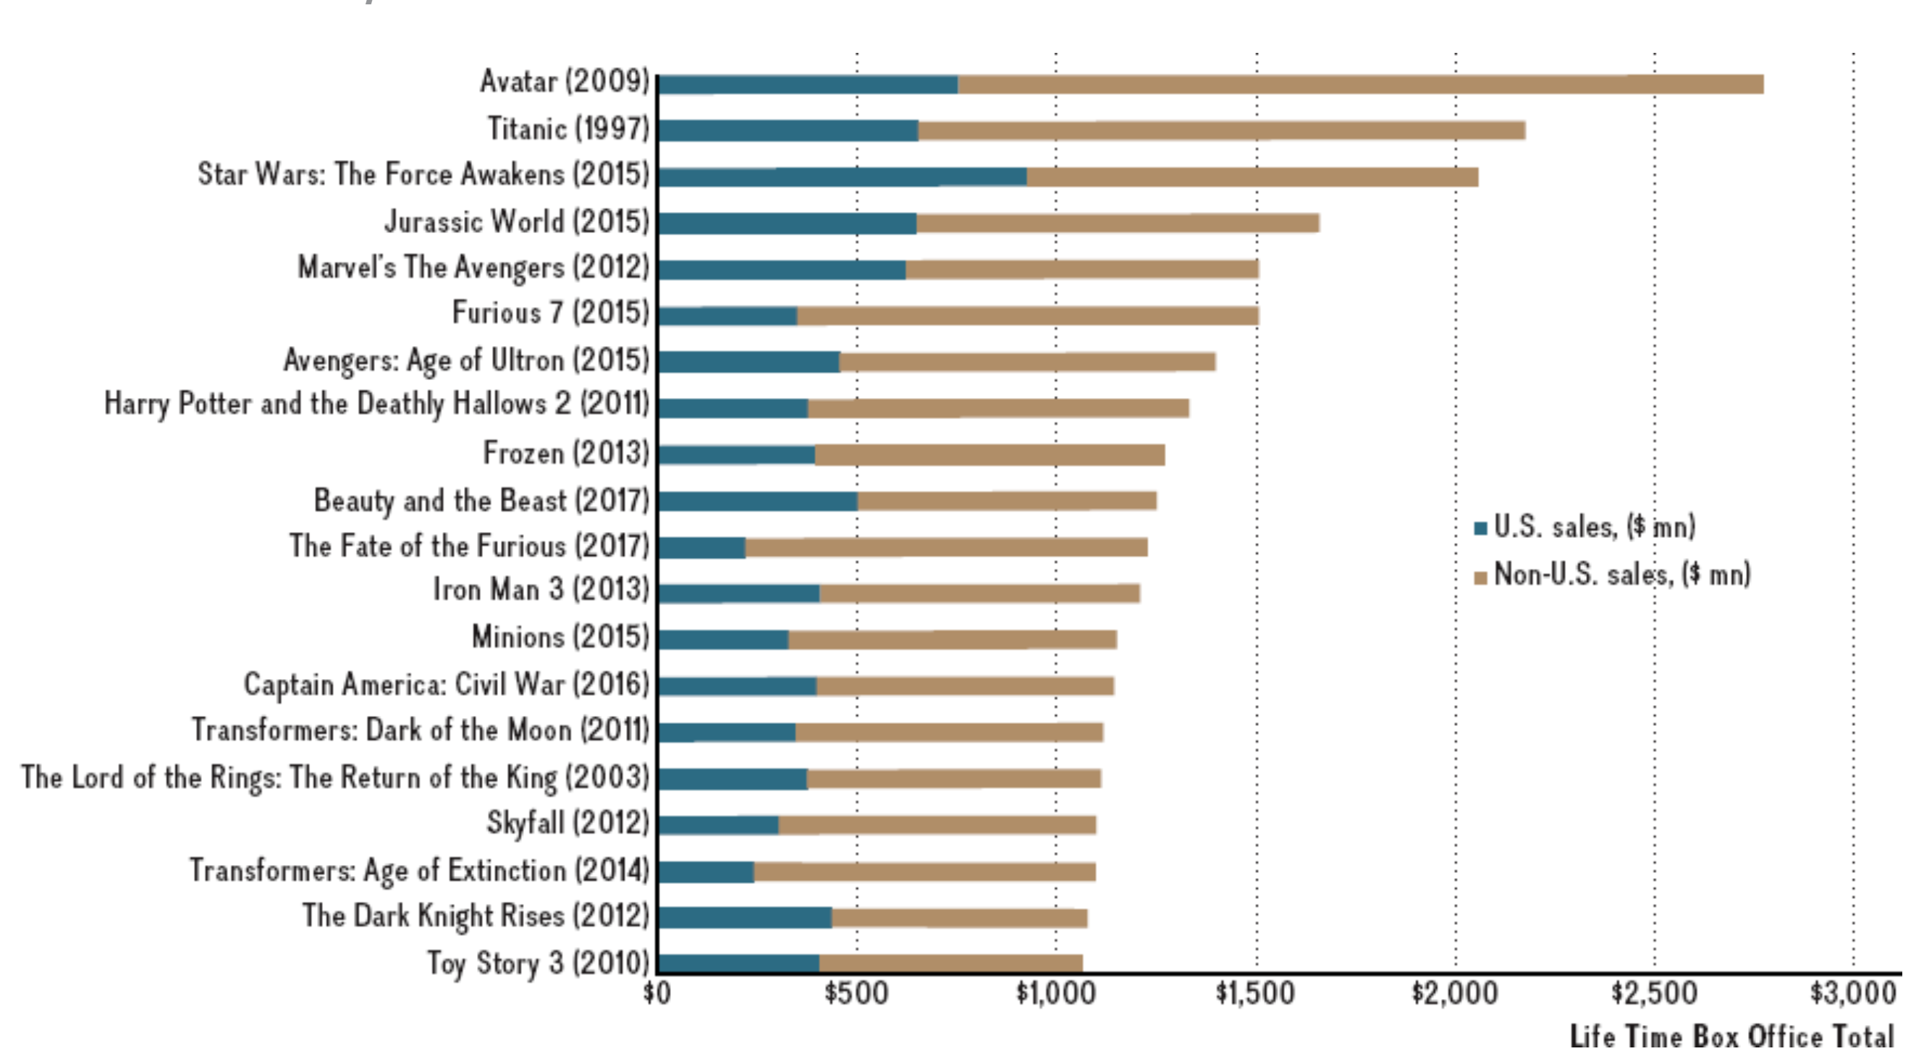
SOURCE: Depiction of data from Box Office Mojo, http://boxofficemojo.com for years 2010–2017.

“We Need Movies That Break Out Internationally”
Given the increasing importance of non-U.S. box-office sales, Hollywood studios are changing their business models. Rob Moore, vice chairman of Paramount Pictures, explains: “We need to make movies that have the ability to break out internationally. That’s the only way to make the economic puzzle of film production work today.”¹ For instance, in 2014, only one film grossed more than $300 million in the U.S. home market (Guardians of the Galaxy). Thanks to international releases, however, 2014 was one of the most profitable for Hollywood. As a result, movie studios have changed a number of tactics. Some mega-releases such as Disney’s Monsters University (the prequel to Monsters, Inc.) premiered first in foreign markets before being shown in the United States. Avengers: Age of Ultron set the record in 2015 for the biggest overseas opening, surpassing a record set weeks earlier by Furious 7, in The Fast and the Furious film series. Unsurprisingly, the record passed back to the eighth movie in The Fast and the Furious film series when it hauled in $44.3 million in the opening weekend, with a whopping 80 percent of its total opening weekend sales coming from screens outside the United States.

With a budget of $150 million, and starring Matt Damon and Jing Tian, The Great Wall is the most ambitious coproduced movie between Hollywood and Chinese film studies to date. The Great Wall is also the most expensive movie ever shot exclusively in China.
©LEGENDARY EAST/ATLAS ENTERTAINMENTKAVA PROD/LE VISION PICTUR/Album/Newscom
Hollywood is also adapting scripts to appeal to global audiences, casting foreign actors in leading roles, and pulling the plug on projects that seem too U.S.-centric. For example, the film G.I. Joe: The Rise of Cobra prominently featured South Korean movie star Byung-hun Lee and South African actor Arnold Vosloo. Although Hollywood has had to release versions of films edited to meet local censorship rules for many years, a recent phenomenon has been the recording of special scenes to cater to audiences in specific markets. Other challenges also loom. In 2014, hackers famously penetrated Sony Pictures and publicly posted damaging internal e-mails as retaliation for the comedy film The Interview, about the assassination of North Korean leader Kim Jong-un.
The fact that Hollywood now garners roughly seven out of 10 dollars of its revenues internationally is somewhat surprising, given several constraints faced by U.S. films when selling internationally. Besides potential government interference with content, there are numerous piracy concerns. Even in the European Union (EU), where some countries impose fines on producers and buyers of pirated content, other countries, such as Spain, have long been havens for the distribution of illegal movies and music. In 2011, Spain passed a law to provide better protection of copyrighted material, but enforcement is notoriously difficult in a country where nearly 50 percent of all internet users admit to illegally downloading copyrighted content (twice the EU average).
Movie studios are moving to simultaneous worldwide releases of expected blockbusters in part to try to cut down on the revenues lost to piracy. Yet growth in China (and elsewhere) is not as profitable as traditional releases in the United States. For example, film distributors typically earn 50 to 55 percent of box-office revenues in America. The average in many other countries is closer to 40 percent (the rest goes to the cinema owner). But in China, a typical Hollywood film distributor gets only 15 percent of the box-office ticket revenue. Moreover, stringent regulations by the Chinese government mean that only a select few page 500Hollywood movies can make it to Chinese theaters. As of 2017, China allows only 34 foreign movie imports a year. The state-backed distributor China Film Group also restricts most Chinese theaters to Chinese films during national holidays, further reducing revenue for Hollywood studios.

China: The Largest Movie Market by 2020
That the economics of the movie industry have fundamentally changed is further demonstrated by the fact that in 2016 China was the second-largest contributor to Hollywood’s top line, with close to $7 billion in annual revenues. China’s overall box-office revenues have tripled between 2013 and 2016. Most impressive, China is poised to exceed the United States in terms of total box-office sales in a few short years, making it the largest movie market globally. Exhibit MC16.2 depicts overall box-office revenues for the United States and China.
EXHIBIT MC16.2 / Box Office Revenue in the United States and China, 2000–2020
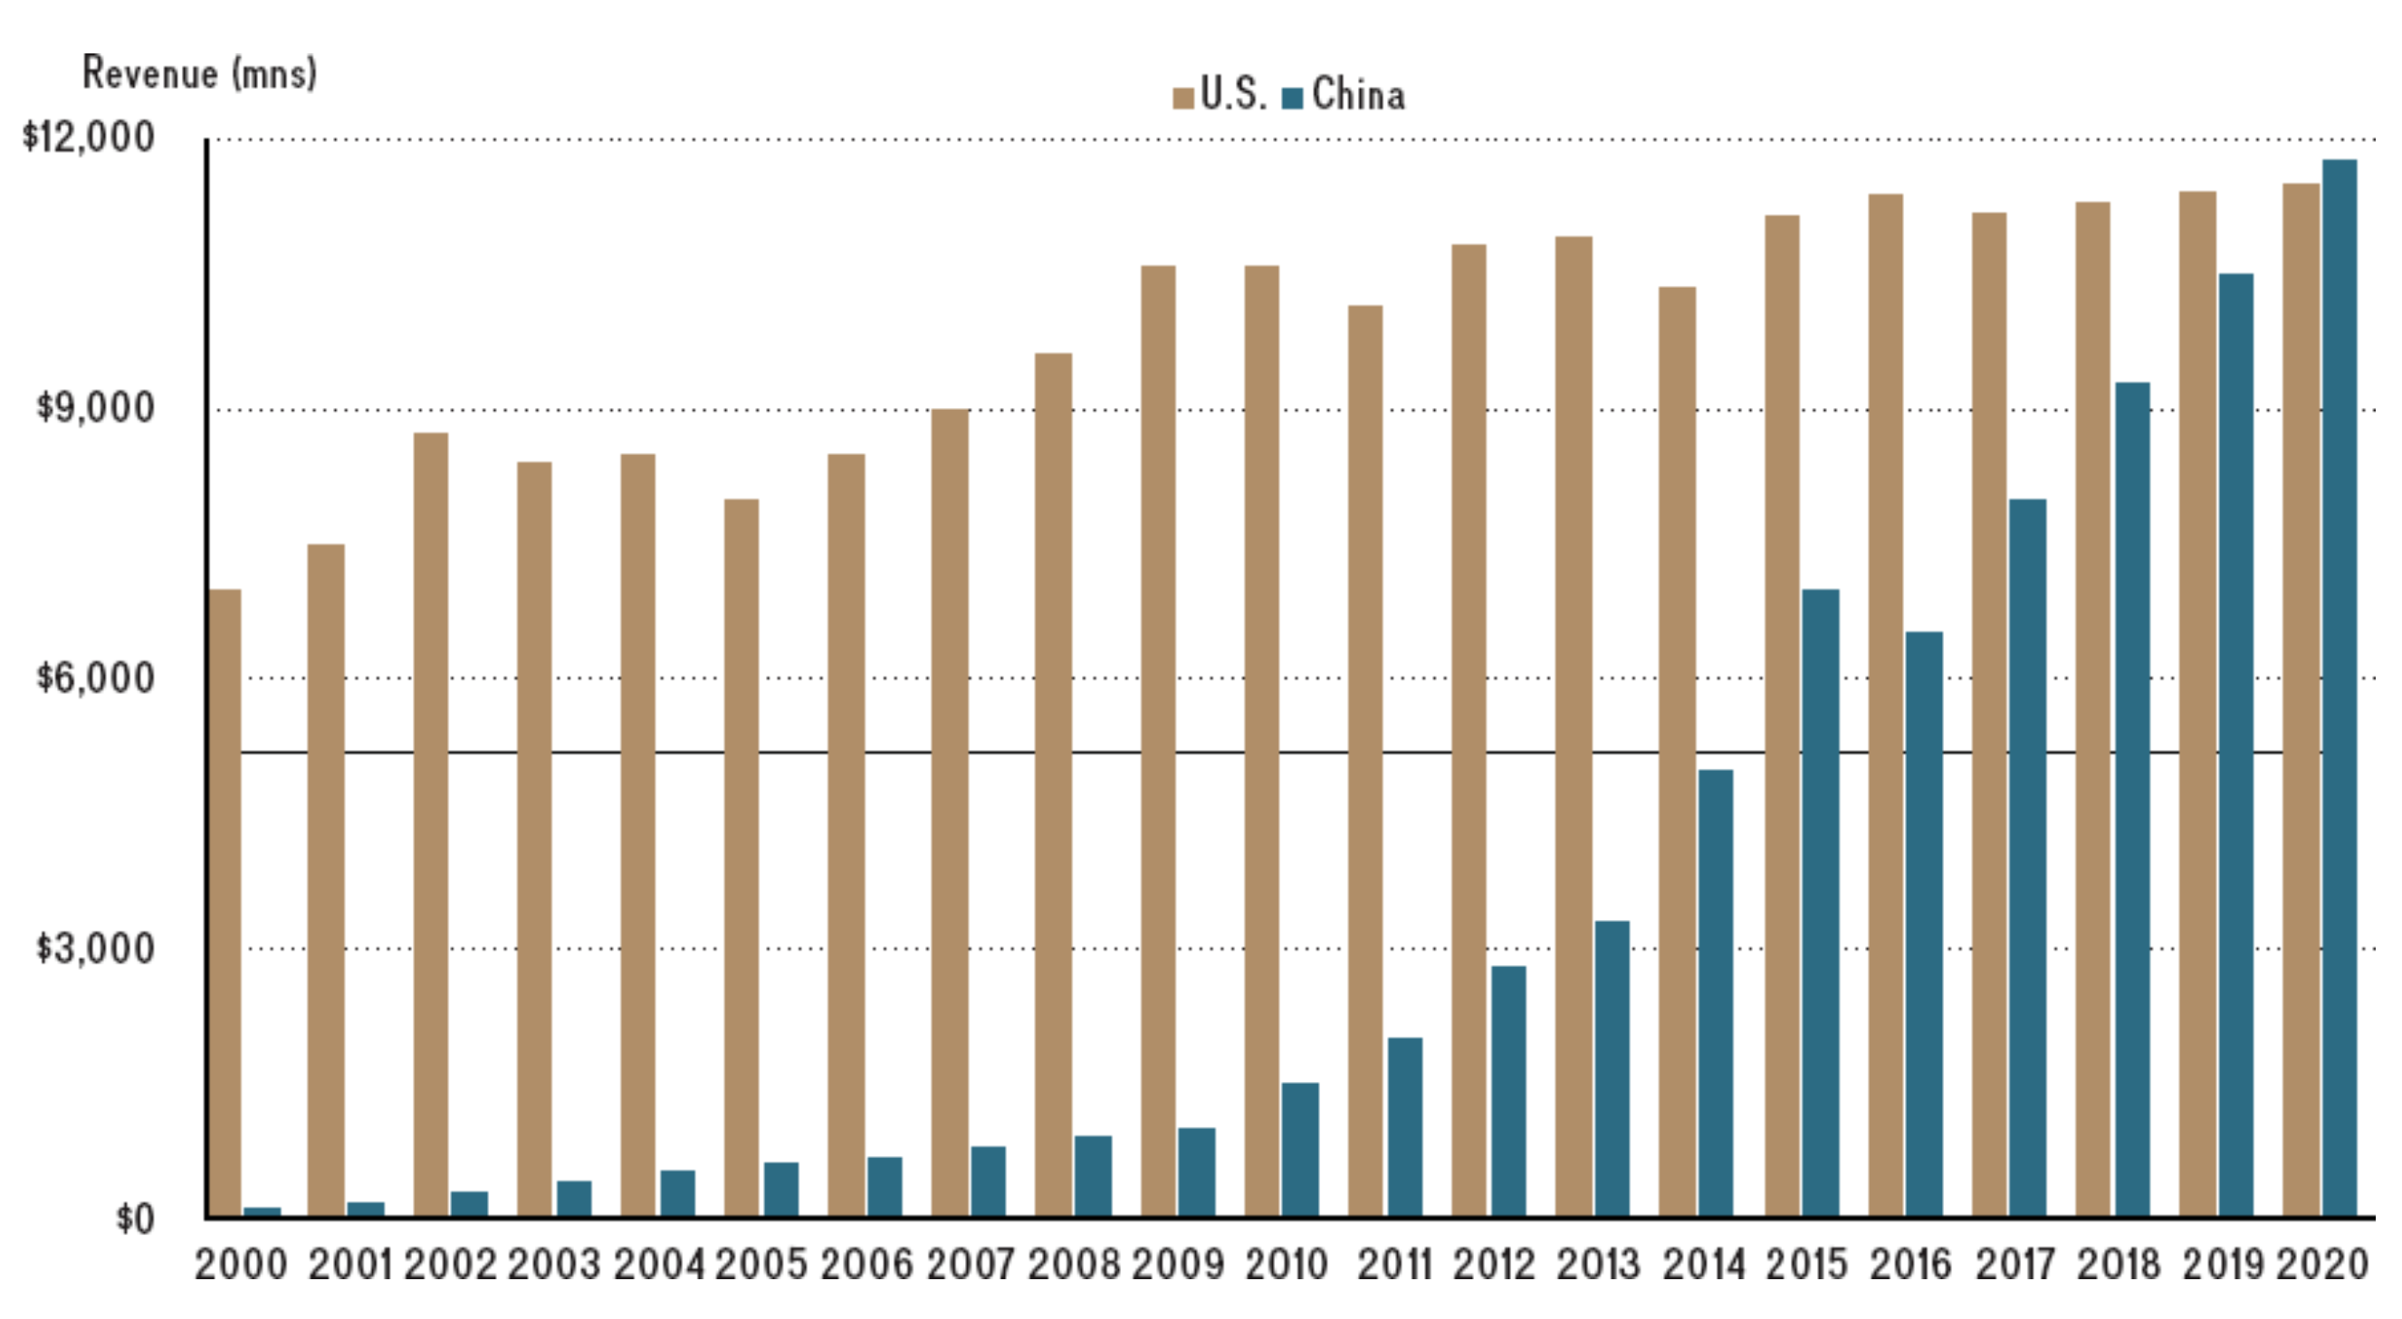
SOURCE: Depiction of data from IHS Markit (with projections for U.S. beginning in 2016 and China in 2017).
Given China’s importance as a movie market, it is no wonder that Hollywood executives aim to please. For instance, Disney’s Marvel Studios produced two versions of the 2013 box office hit Iron Man 3. One version was produced for general release, and another version was specifically targeted for Chinese moviegoers. This version included bonus footage in Beijing and guest appearances by Chinese movie stars. In addition, the hits Mission Impossible III and Skyfall were edited for the Chinese market to cut scenes that Chinese censors thought portrayed China in a negative light, even though several key scenes from these films were set in China.
Some critics assert that Hollywood’s accommodating of Chinese preferences is going too far, and amounts to pandering. For instance, in The Martian, released in 2015, NASA had to accept help from its counterpart, the China National Space Administration, to provide a classified booster rocket that would carry payload to Mars and thus allow NASA (which did not have such an advanced rocket at its disposal) to rescue its stranded astronaut.
The Great Wall (released in China in December 2016 and in the United States in February 2017) marked a new level of U.S.-China collaboration in page 501movie production. Directed by Zhang Yimou, who rose to fame when he choreographed the opening and closing ceremonies of the 2008 Beijing Summer Olympic Games, the movie co-stars Damon and Jing Tian. Damon plays a European mercenary who joins forces with a Chinese commander, played by Jing Tian, to fight mysterious invaders at the Great Wall. With a mega-budget of $150 million, The Great Wall is the most ambitious coproduction between Hollywood and Chinese film studies to date. It is also the most expensive movie ever shot exclusively in China. As an official coproduction between U.S. and Chinese companies, The Great Wall combines cast and effects from both countries and could offer a template for future American-Chinese movies.
Although the hope was that The Great Wall would appeal to both Chinese and U.S. audiences, the movie flopped in the United States. Critics highlight the difficulties of creating movies that blend Eastern and Western stories and characters. To produce The Great Wall, the companies had to retain more than 100 interpreters to deal with conflicts among cast and crew members based on different cultural understandings. In the United States, The Great Wall made only some $35 million, against a total estimated loss of $75 million. Yet movie studios are undeterred. They admit that although The Great Wall was a commercial failure, they blame that in part on negative reviews. Movie executives continue to highlight the huge market opportunities in China and emphasize that they will soon find the right formula to make movies that are attractive to both U.S. and Chinese audiences.

Challenges with the Chinese Market
Although the Chinese market clearly provides a potentially huge upside for Hollywood, this opportunity does not come without its challenges. One serious challenge is content editing by government officials before screening. The Oscar-winning film Django Unchained saw its release in China temporarily canceled due to “technical reasons,” which were interpreted to mean excessive violent and sexual content. By the time the film was recut and released, it performed poorly, in part driven by the fact that many Chinese filmgoers had already seen the film unedited on pirated DVDs. The remake of the film Red Dawn was digitally edited in postproduction to change the invading Chinese army to an army from North Korea to avoid offending the Chinese consumer (and government officials approving the screening of foreign movies).
China is also infamous for rampant infringement of copyright, resulting in a flourishing market for bootleg content. In 2010, a Chinese government report found that the market for pirated DVDs was $6 billion. As a comparison, the total box-office revenues in China in 2010 were a mere $1.5 billion. One reason is that ticket prices for movies in China are steep and movies are still considered luxury entertainment that few are willing to pay for. Another reason that black-market sales in China are so high is that legitimate sales often are not allowed. As mentioned, China allows only a few dozen new non-Chinese movies into its theaters each year. Additionally, it has strict licensing rules on the sale of home-entertainment goods. As a result, there is often no legitimate product competing with the bootleg offerings available via DVD and the internet in China.
With the move from physical media such as DVDs and Blu-ray discs to online streaming, Chinese streaming and video-on-demand services are growing rapidly. In 2016, PPTV, a Chinese online streaming website, secured the post-theater rights to Warcraft for $24 million, indicating a potentially new source of revenues for Hollywood. While Netflix does not yet do business directly in China, and the government blocks computers in China from accessing Netflix’s service, it is estimated that 20 million Chinese access Netflix using proxy servers that mask the actual location of the user’s machine. Netflix’s original series House of Cards has been a huge success not only in the United States but also in China. In 2017, Netflix came one step closer to directly accessing the China market. It signed a licensing agreement with video platform IQiyi, owned by Chinese internet search company Baidu, which will stream its original content. Netflix content, however, could give Chinese regulators pause. The House of Cards plotline, for example, involves a corrupt Chinese businessman operating at the highest level of politics.

Enter Bollywood
The huge opportunities in the global movie market have also attracted new entrants. Besides wanting to cater to international audiences, Hollywood film studios are also feeling squeezed by low-cost foreign competition. While certainly not number one in terms of revenue, India’s Bollywood films have long been page 502king in terms of total ticket sales. Although generally smaller-budget productions than Hollywood, the Hindi film industry in Bollywood produces four times as many films per year. Moreover, Bollywood brings in low-cost but high-impact actors such as Freida Pinto and Dev Patel, who played the lead roles in the mega-success Slumdog Millionaire. Slumdog’s budget was merely $14 million, but the movie grossed almost $400 million and won eight Oscars. By comparison, Hollywood’s budget for Home Alone, a similar success in terms of revenues, was nearly five times as large. Globalization also puts pressure on the pay of Hollywood stars. Given the importance of international audiences and the availability of foreign stars and movies, the days are over when stars such as Tom Hanks, Angelina Jolie, Denzel Washington, or Julia Roberts could demand 20 percent royalties on total ticket sales.

DISCUSSION QUESTIONS
- How has the global environment changed for U.S. (Hollywood) movie studies since 2000? Explain.
- Apply the integration-responsiveness framework to describe which global strategy Hollywood studios followed originally, and how their strategic positioning has changed over time. Explain how and why.
- When commenting on the disappointing performance of The Great Wall, movie executives continue to highlight the huge market opportunities in China, and emphasize that they will soon find the right formula to make movies that are attractive to both U.S. and Chinese audiences. Do you agree with this assessment? Why or why not?
- Assuming that movie studios will be able to create breakthrough hits that are attractive for both Eastern and Western audiences, what type of global strategy would that entail? What are some benefits of this type of global positioning? What are some of its risks? Why is this type of global positioning so hard to achieve?
- What can movie producers do to ensure that future Chinese-U.S. co-productions are more successful? Explain.

